


Lost and Found Reporting System
(FindMe)

Prepared and Presented by:

Menadel Miguel
Mikee Miguel
Jay-R Dagami
Sean Plaza

S3101 | Group 13
Bachelor of Science in Information Technology
Term 1 SY. 2026-2027

Intellectual Property Notice

This template is an exclusive property of Mapua-Malayan Digital College and is protected under Republic Act No. 8293, also known as the Intellectual Property Code of the Philippines (IP Code). It is provided solely for educational purposes within this course. Students may use this template to complete their tasks but may not modify, distribute, sell, upload, or claim ownership of the template itself. Such actions constitute copyright infringement under Sections 172, 177, and 216 of the IP Code and may result in legal consequences. Unauthorized use beyond this course may result in legal or academic consequences.

Additionally, students must comply with the Mapua-Malayan Digital College Student Handbook, particularly with the following provisions:
- Offenses Related to MMDC IT:
  - Section 6.2 – Unauthorized copying of files
  - Section 6.8 – Extraction of protected, copyrighted, and/or confidential information by electronic means using MMDC IT infrastructure
- Offenses Related to MMDC Admin, IT, and Operations:
  - Section 4.5 – Unauthorized collection or extraction of money, checks, or other instruments of monetary equivalent in connection with matters pertaining to MMDC
Violations of these policies may result in disciplinary actions ranging from suspension to dismissal, in accordance with the Student Handbook.

For permissions or inquiries, please contact MMDC-ISD at isd@mmdc.mcl.edu.ph.

Table of Contents

TABLE OF CONTENTS 3
I. Project Documentation 4
A. Project Information 4
B. Project Repository Information 5
II. Backend-Supported Features Analysis 6
III. Completed Implementation Work 8
IV. Implementation Dependencies 9
A. Key dependencies 11
V. Workflow Updates and Revisions 11
VI. Deployment 13
VII. App Development Workflow 13
VIII. Development Reflections 15
A. What worked well 15
B. What needs improvement 16
IX. Team Discussion Outcomes 16
X. Testing Evidence 18

Project Documentation

Project Information
Item | Details
Project Title | Lost and Found Reporting System (FindMe)
Project Type | Web-Based Information System
Project Purpose | To provide a centralized platform for reporting, searching, and managing lost and found persons, pets, and items.
Target Users | General Users and System Administrators
Main Problem Addressed | Lost-and-found information is often scattered across social media posts, group chats, and other platforms, making reports difficult to organize and find.
Main Goal | Make lost-and-found information easier to submit, search, view, and manage.
Development Approach | Object-Oriented Systems Analysis and Design (OOSAD)
The Lost and Found Reporting System (FindMe) is designed to provide one centralized platform where users can report lost or found persons, pets, and items. Users can provide important information such as descriptions, dates, locations, photos, and contact details. Administrators can manage submitted reports and help maintain organized and appropriate information.

Project Repository Information
The project repository contains the documents, diagrams, designs, and other files needed for the development of the Lost and Found Reporting System.
Github: https://github.com/mgmiguel24/webssystemsandtechnology-Group13-lostandfoundreportingsystem

Repository Content | Description
Project Proposal | Background, problem statement, objectives, proposed solution, and scope
Milestone 1 Documentation | Interactive Frontend Web Application documentation (DOCX and PDF)
Backend Application (findme-api) | Milestone 2 Express.js API, SQLite database, web interface, and automated tests
Live Prototype (Milestone 1) | Milestone 1 prototype
Live System (Milestone 2) | Deployed backend web application on Render
Class Diagram | Main classes, attributes, methods, and relationships of the system
Component Diagram | Major software components and how they interact
UI/Prototype Design | Planned interface screens and user interactions
The repository is updated through reviewed pull requests, so the main branch always holds the latest working version.

Backend-Supported Features Analysis
The Milestone 1 prototype simulated backend behavior in the browser using localStorage. In Milestone 2, we moved these features to an Express.js server with a SQLite database, so data is shared across users and every permission is enforced on the server.
Feature | Milestone 1 Prototype | Milestone 2 Implementation
User registration | Saves user information in localStorage | Registration API; passwords hashed with bcrypt
Login and logout | Checks credentials in the browser | Server-side authentication with a secure session cookie that expires after 24 hours
User roles | Role selected during registration | Roles assigned by the server; sign-up always creates a regular user
Lost and found reports | Saves reports locally | Stored in a SQLite database through the API
Search and filters | Filters reports in the browser | Server-side search with filters for type, category, status, and a date range
Report editing | Not available in the prototype | Owner or admin can edit a report; every edit is logged in its history
Report status | Owner or admin can change status in the prototype | Server verifies ownership or admin role before any change
Delete report | Admin-only interface check | Admin-only, enforced on the server; deleted reports are kept for the audit trail
Photo upload | Stores images as Base64 data | Saved as files on the server; JPEG, PNG, WebP, or GIF up to 5 MB
Contact information | Visible in the report detail modal | Hidden from guests; shown only to signed-in users
Dark mode | Theme toggle, not saved | Theme choice saved in the browser and restored on the next visit
Moving these checks to the server closed the security gaps in the prototype, where any permission could be bypassed by editing browser data. Authentication, role authorization, privacy, and data storage are now handled by the backend.

Completed Implementation Work
The following features are implemented in the current system.
- Responsive interface with a card-based report layout.
- Light and dark theme toggle, with the choice saved between visits.
- User registration, login, and logout handled by the server.
- Header displaying the logged-in user’s name and role.
- Lost and found report submission for people, pets, and items, with an optional photo.
- Report details including location, date, description, contact information, and case history.
- Keyword search with filters for type, category, status, and a date range.
- Report editing by the report owner or an administrator.
- Mark as Resolved and Reopen actions, with a confirmation step, for report owners or administrators.
- Delete action restricted to administrators on the server; deleted reports are kept for the audit trail.
- Contact details hidden from guests and shown only to signed-in users.
- Administrator tools to list users and change roles, with protection against removing the last administrator.
- Rate limiting on login attempts and report submissions.
- An administrator account and 5 sample reports created automatically for testing.

Current status: The frontend and backend are both implemented and connected. Authentication, role-based authorization, and report management are handled server-side via the Express.js API. The application has been tested with an automated test suite and deployed publicly on Render.

Implementation Dependencies
The following components are used in the current system.
Component | Purpose | Status
HTML, CSS, JavaScript | Build the browser interface and interactions | Implemented
Tailwind CSS | Style the responsive interface | Implemented
Phosphor Icons | Provide interface icons | Implemented
Browser localStorage | Remember the user’s theme choice | Replaced by the API for all data; now only remembers the theme
Node.js and Express.js | Build backend services and REST API routes | Implemented
Database (PostgreSQL or SQLite) | Persistent storage for users and reports | Implemented
bcryptjs | Password hashing | Implemented
jsonwebtoken + httpOnly cookies | Session authentication | Implemented
multer | Photo upload handling, with file-type validation | Implemented
zod | Request validation | Implemented
helmet, express-rate-limit | Security headers and rate limiting on auth and report creation | Implemented
node:test (automated test suite) | Verifies auth, report, and admin behavior end-to-end | Implemented
Render (hosting) | Public deployment | Implemented — free tier, see limitations below

Key dependencies
- Frontend and backend are fully connected; all fetch() calls in the UI point to live API endpoints.
- Database schema is finalized and in use (users, reports, report_events).
- Authentication and role-based authorization are enforced on every protected route.
- Photo uploads are validated and stored as real files, not embedded as Base64.

Workflow Updates and Revisions
We followed a prototype-first workflow: build the interface, test the user journey, identify problems, and resolve them during backend integration. The table records each issue found in Milestone 1 and how we resolved it in Milestone 2.
Area | Issue identified | Resolution | Status
Authentication | Passwords are stored in plain text | Passwords are hashed with bcrypt, and login runs on the server | Resolved
User roles | Users can select the admin role during registration | Role selection removed; sign-up always creates a regular user, and only an admin can promote users | Resolved
Contact privacy | Contact details are visible to visitors | Contact details are hidden from guests and shown only to signed-in users | Resolved
Image storage | Base64 images can exceed storage limits | Photos are saved as files on the server, limited to 5 MB and image formats only | Resolved
Dark mode | Theme may not apply consistently | Theme class moved to the page root so dark mode applies to the whole page | Resolved
Theme persistence | Theme selection is lost after reload | Theme choice is saved and restored on the next visit | Resolved
Search and filters | Date filtering supports only an exact date | Added From and To date range filters | Resolved
Report management | No report editing or confirmation before status changes | Added an Edit Report form for owners and admins, and a confirmation before status changes | Resolved
Input validation | Future report dates are accepted | Future dates are blocked in the form and rejected by the server | Resolved
Interface consistency | Different system names appear in the interface | Header, footer, and page title now consistently use FindMe | Resolved

Deployment
The application is deployed on Render (free tier) and publicly accessible at: https://find-me-tx2o.onrender.com
Known limitations of the current deployment:
- The free tier has no persistent disk. The SQLite database and uploaded photos reset to seeded sample data whenever the service restarts, redeploys, or wakes from sleep.
- The free tier sleeps after approximately 15 minutes of inactivity; the first request afterward can take 30–50 seconds to respond while the service wakes up.
- These are hosting-tier constraints, not application bugs. A paid tier with a persistent disk, or migration to a hosted database service, would resolve both issues for a production deployment.

App Development Workflow
The backend was built in the following order, so that each stage could be tested before the next depended on it:
Phase | Work | Outcome
1. Setup & Schema | Set up the Express project structure (routes/, controllers/, models/, middleware/); design the database schema (users, reports, report_events); configure environment variables | Project skeleton and database schema in place
2. Authentication | Build registration, login, logout; implement password hashing and JWT session cookies; enforce that registration can never create an admin | Secure, working login system
3. Core Report Features | Build report creation, listing, search/filter, status change, and soft delete, each with server-enforced permissions | Reports can be created, found, and managed through the API
4. Photo Upload & Access Control | Add multer-based photo upload with file validation; apply requireAuth, requireRole, and ownerOrAdmin middleware across all protected routes | Uploads and permissions fully server-side, replacing the prototype’s browser-only checks
5. Testing | Write an automated end-to-end test suite (http://api.test.js) covering guest, user, and admin flows | Confidence that core features work correctly before extending them
6. Enhancements | Add report editing, last-admin protection, date range filtering, and rate limiting on report creation | Closed the remaining gaps identified in the Workflow Updates table
7. Deployment | Deploy to Render; connect GitHub for automatic redeploys on push; configure environment variables and seed data | Publicly accessible, working application
8. Frontend Integration | Replace all localStorage calls in the prototype with fetch() calls to the live API | Frontend and backend fully connected

Development Reflections

What worked well
- Automated testing before deployment. We wrote 22 automated tests covering sign-up, login, permissions, privacy, search, editing, and admin safeguards. Running them before each merge caught issues early, such as an unclear error message on an empty login, which we fixed before deploying.
- Pull request workflow. Every backend change went through a pull request that was reviewed before merging. This kept the main branch stable and gave us a clear record of who changed what.
- Layered backend structure. Splitting the backend into routes, controllers, models, and middleware made each feature easier to build and test separately, which fixed the single-file problem we noted in Milestone 1.
- Prototype-first foundation. The Milestone 1 interface gave us a working user journey to build on, so the backend could replace browser storage without redesigning the screens.

What needs improvement
- Deploying on Render’s free tier showed that data resets when the server restarts, something local testing never revealed. A future version should use persistent storage or a hosted database.

Team Discussion Outcomes

Discussion topic | Decision/ Outcome
Backend technology | We built the backend with Node.js and Express.js to handle the REST API, authentication, and report management.
Database | We selected SQLite to store user accounts, reports, and a history log of every report action.
Authentication | Registration, login, and logout run on the server. Passwords are hashed with bcrypt and never stored as plain text. Sessions use a secure cookie that expires after 24 hours. Login attempts and report submissions are rate limited to block password guessing and spam.
User permissions | The admin account is created from server settings, and the sign-up form ignores any request for admin access. Report owners and admins can edit a report and update its status, only admins can delete reports, and admins can promote other users. The system blocks removal of the last remaining admin.
Report management | We finalized report creation, search, filtering, editing, status updates, and deletion. Search supports a date range, and future dates are rejected. Every edit is recorded in the report’s history, and deleted reports are hidden rather than erased, so admins keep a record.
Privacy | Contact details are hidden from guests and shown only to signed-in users. Report lists never include contact information.
Photo uploads | Photos must be JPEG, PNG, WebP, or GIF and no larger than 5 MB. The server checks the actual file contents, not just the file name, and saves each photo under a random name.
Testing | We wrote 22 automated tests covering security, sign-up, login, permissions, privacy, search and date filters, report editing, admin safeguards, rate limiting, and deletion. We also tested the live deployment across guest, user, and admin flows.
Deployment | The system is deployed on Render’s free tier. We accepted that data and uploaded photos may reset on server restart, since the free plan has no permanent storage.
Version control | Changes go through pull requests and are reviewed before merging into the main branch. Merged branches are deleted to keep the repository clean.
Task assignments | Jay-R Dagami: Backend development, documentation and deployment.  Sean Plaza: README documentation.  Mikee Miguel: Pull request review and merging, README documentation, and final documentation  Menadel Miguel: Frontend design prototype and documentation

Testing Evidence
We tested the live deployment at https://find-me-tx2o.onrender.com across guest, regular user, and administrator flows. The screenshots below show each core feature working on the deployed system.

Demo login
Role | Email | Password
Admin | admin@findme.local | SystemAdminGroup13
Regular user accounts can be created through the Register Account form.

- Guest view: reports listed, contact details hidden.
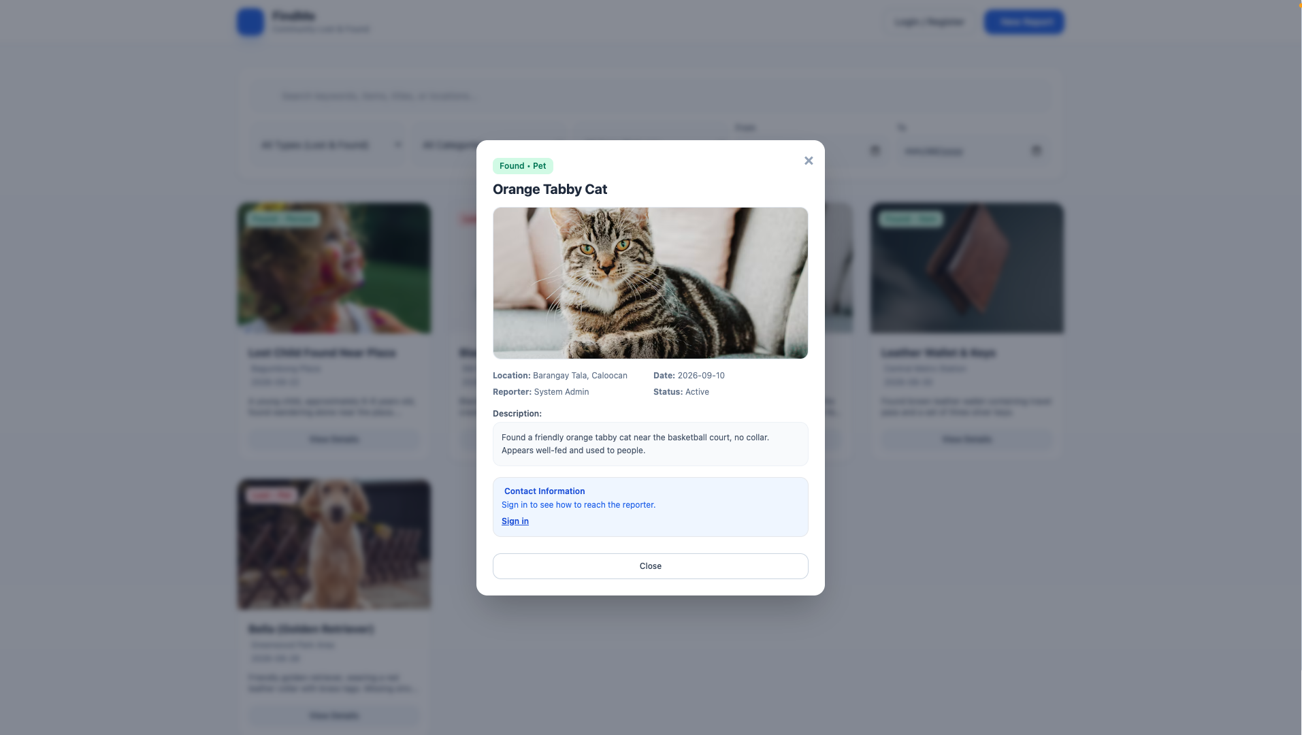

Figure1: https://github.com/mgmiguel24/webssystemsandtechnology-Group13-lostandfoundreportingsystem/blob/main/Testing%20Evidence/Figure%201%20.png

- Registration of a new regular user account.
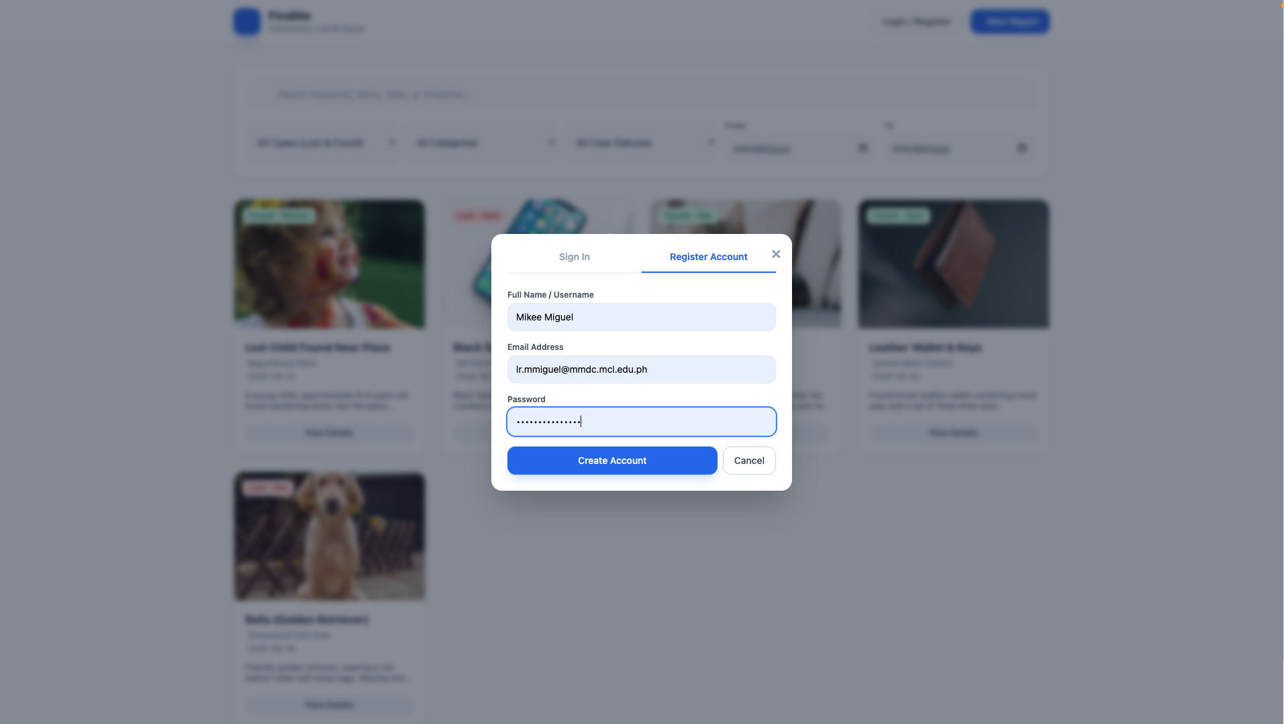
Figure 2: https://github.com/mgmiguel24/webssystemsandtechnology-Group13-lostandfoundreportingsystem/blob/main/Testing%20Evidence/Figure%202.png
- Signed-in user filing a new report with a photo.
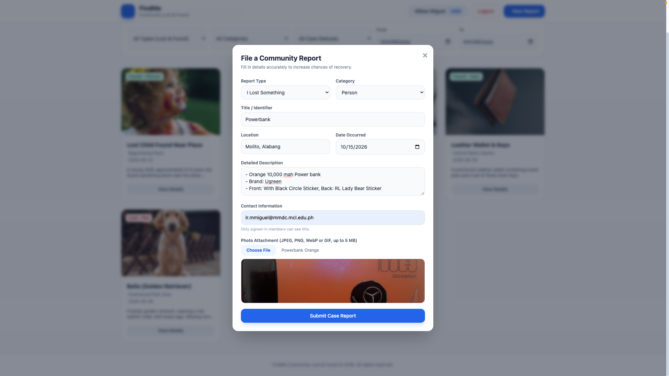
Figure 3: https://github.com/mgmiguel24/webssystemsandtechnology-Group13-lostandfoundreportingsystem/blob/main/Testing%20Evidence/Figure%203.png

- Search with the From and To date range filter applied.
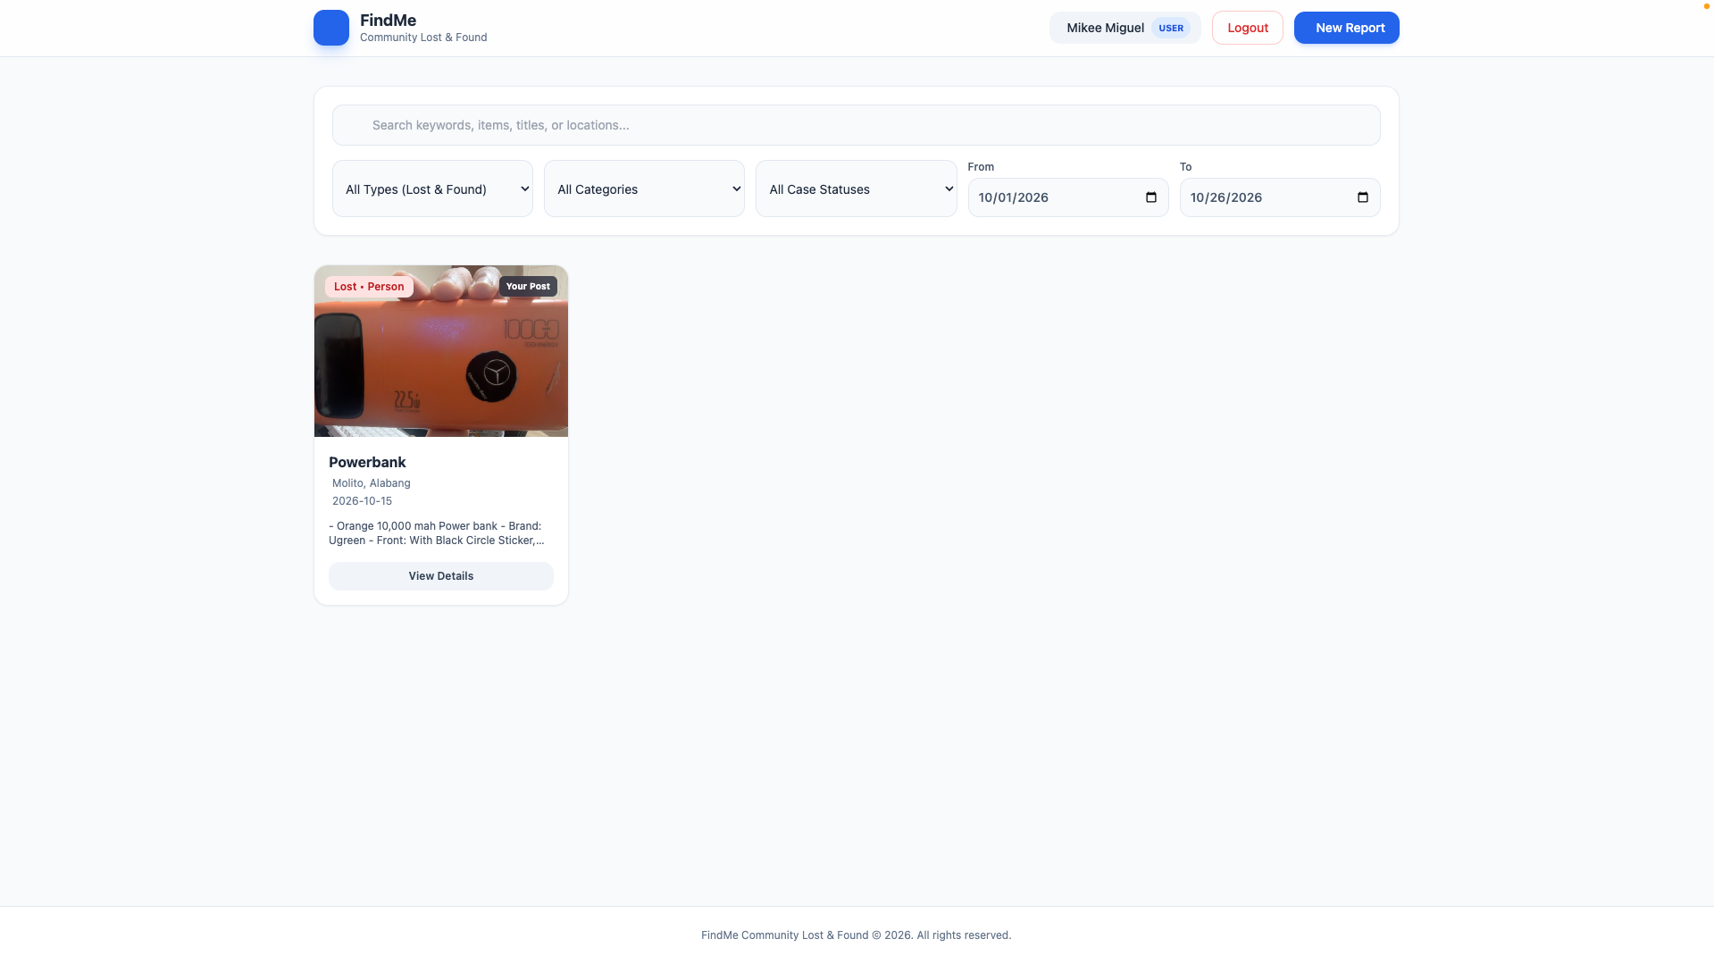
Figure 4: https://github.com/mgmiguel24/webssystemsandtechnology-Group13-lostandfoundreportingsystem/blob/main/Testing%20Evidence/Figure%204.png
- Report owner editing a report.
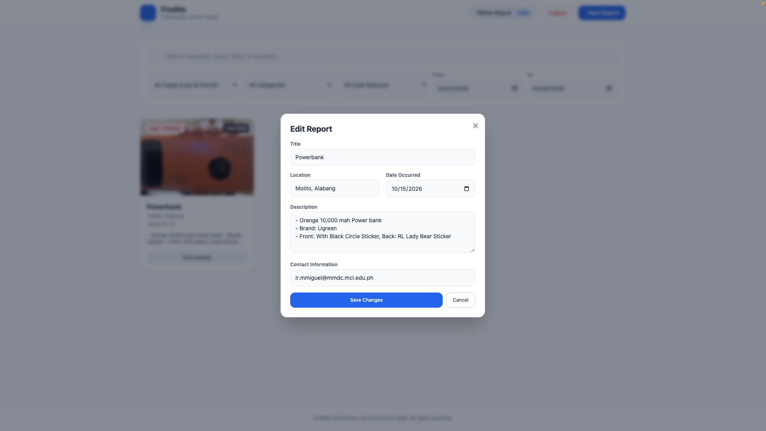
Figure 5:
https://github.com/mgmiguel24/webssystemsandtechnology-Group13-lostandfoundreportingsystem/blob/main/Testing%20Evidence/Figure%205.png

- Report marked as Resolved, with the update shown in its case history.
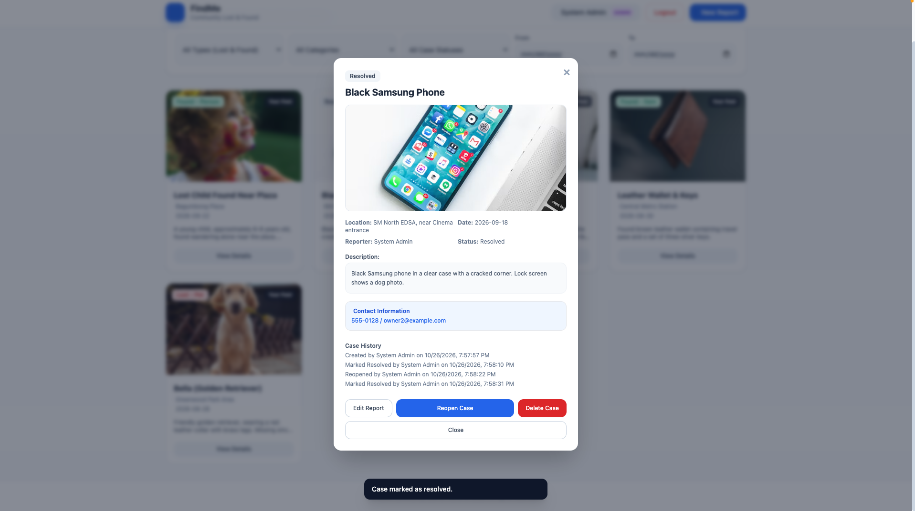
Figure 6: https://github.com/mgmiguel24/webssystemsandtechnology-Group13-lostandfoundreportingsystem/blob/main/Testing%20Evidence/Figure%206.png
- Admin deleting a report, with the confirmation prompt.
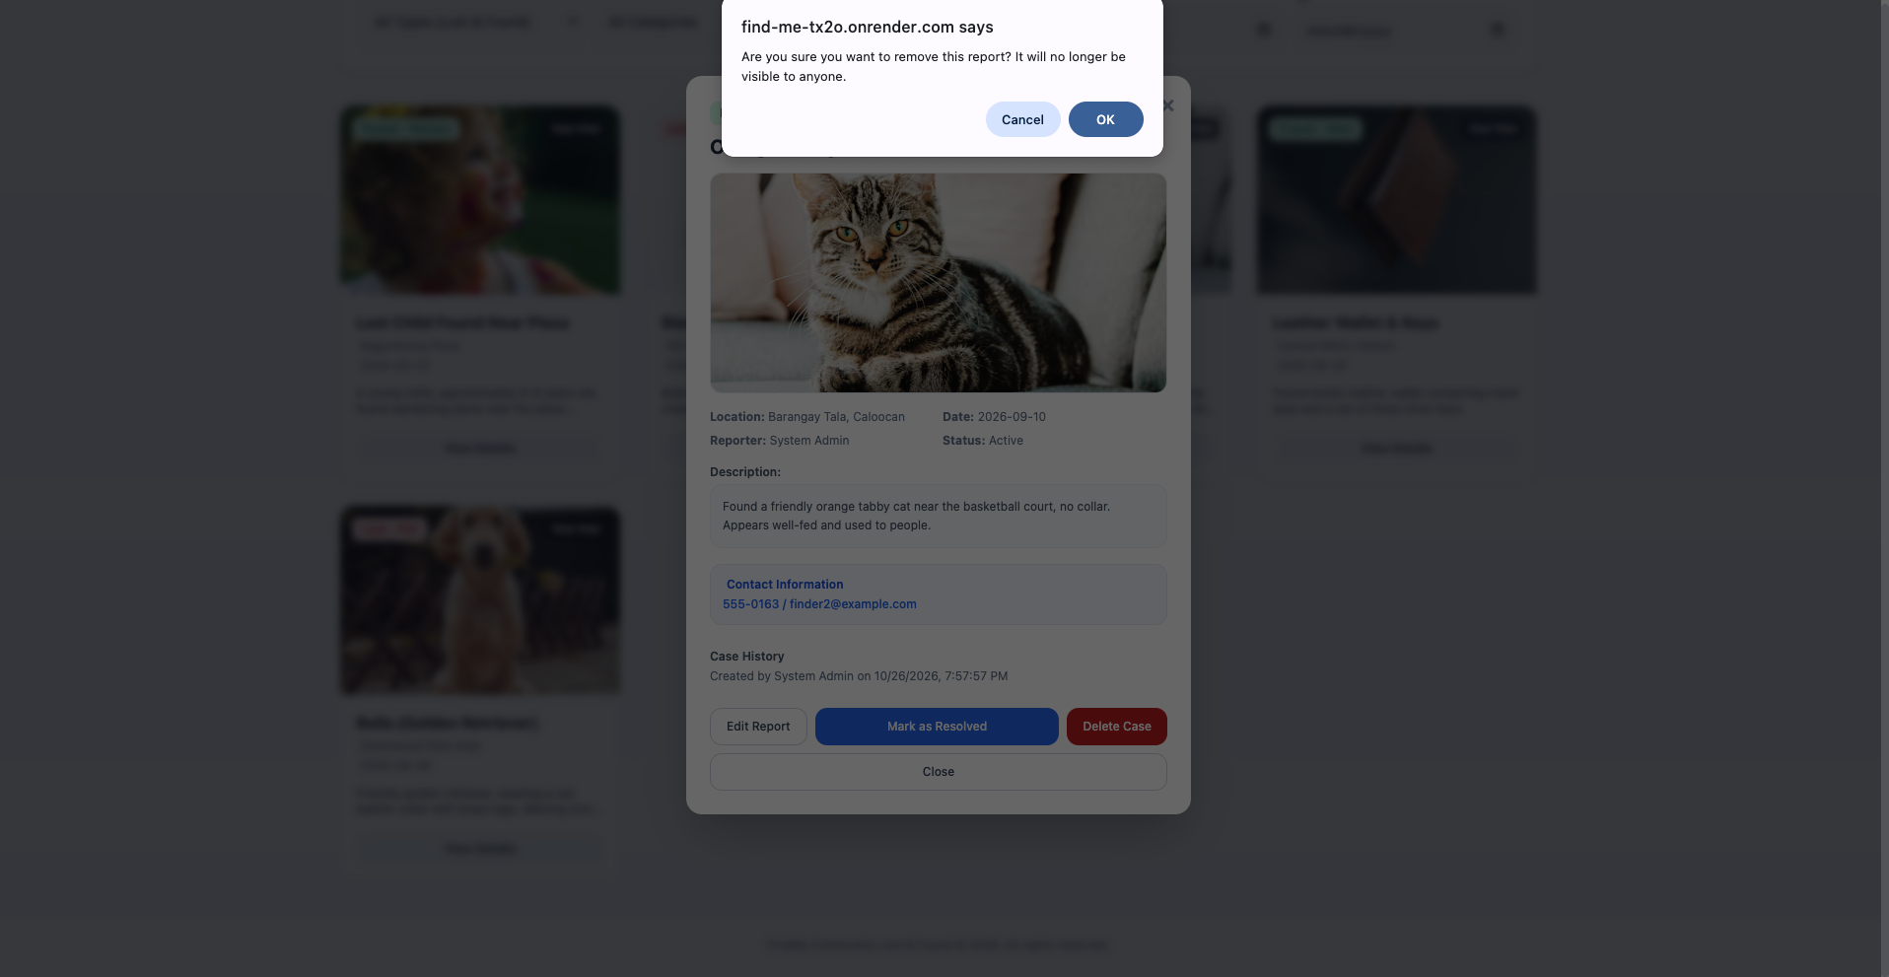
Figure 7: https://github.com/mgmiguel24/webssystemsandtechnology-Group13-lostandfoundreportingsystem/blob/main/Testing%20Evidence/Figure%207.png
- Automated test results from npm test
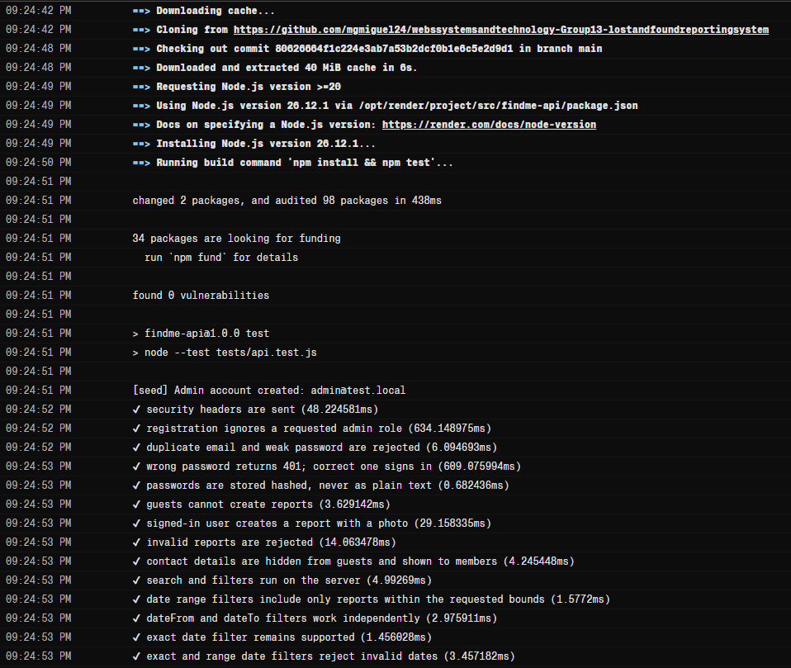
Figure 8.1:
https://github.com/mgmiguel24/webssystemsandtechnology-Group13-lostandfoundreportingsystem/commit/87d04541c967f2635c8fd347de0d90c9c6774232
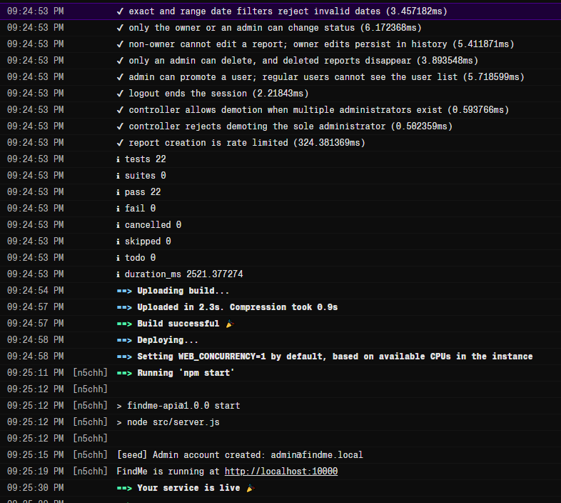
Figure 8.2:
https://github.com/mgmiguel24/webssystemsandtechnology-Group13-lostandfoundreportingsystem/blob/main/Testing%20Evidence/Figure%208.2

